Grantown YMCA Community Centre
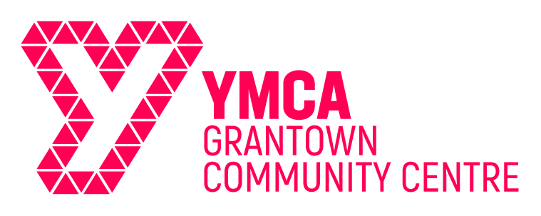
Membership Application Form

To apply for membership of Grantown YMCA Community Centre, please complete this form
'The Grantown YMCA Community Centre is a charitable organisation which is dedicated to supporting and enriching the community and individuals at every stage of life. We share and promote the Christian based values of the YMCA which include Honesty, Caring, Respect, Responsibility and Inclusiveness. We are open for membership to people aged 16 and over of all faiths – or of none, who live by and support these values.

Declaration
I/The organisation would like to be a member of Grantown YMCA Community Centre. Please enrol me/us in the following membership category:
Membership type | Criteria |  |  | Name(s) of Members
 |  |  |  | Title(s) | Name(s)
Full | Open to individuals who support the aims and purposes of the Grantown YMCA Community Centre.
Associate | Open to individuals, groups or organisations which avail themselves of the use of the Centre and support the work of the Grantown YMCA Community Centre |  |  | Group/Org
 |  |  |  | Your Name
 |  |  |  | Position in Org.
Address |  | Tel No.
 |  | Postcode
 |  | Email
Remit of Group/
Organisation

* All of the information supplied will be held by Grantown YMCA Community Centre and will not be shared with any other party
Signature
(only one required per form, an electronic signature may be used)
 |  |  |  |  |  | Date
Thank you for completing this form. Please SAVE, then send to the address or email below

Grantown YMCA Community Centre, 80 High Street, Grantown on Spey. PH26 3EL
Email; grantowncommunitycentre@gmail.com
SC022363

